**Assignment-16**

**Creation of delta table:**

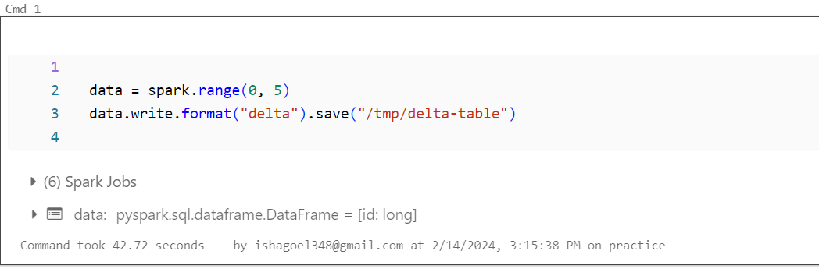

**Reading data from delta table:**

**Updating and reading data:**

